Potential Free Response Topics

- Chi-Square Genetics Problem

Problem 1. In a flowering plant, white flowers (B) are dominant over red (b), and short plants (E) are dominant over tall (e) plants. When two double heterozygote (BbEe) plants were crossed, the resulting phenotypes were observed:
White, short = 206
Red, short = 83
White, tall = 65
Red, tall = 30
Perform a chi-square test to determine if the traits follow a Mendelian inheritance pattern.

Problem 2. In dogs, the Black allele B is dominant to the brown allele b for fur.
A pair of dogs (one brown and one black) were bred and had 20 puppies. 13 puppies were black and 7 were brown.
Calculate the chi-squared value for the null hypothesis that the black haired parent was heterozygous for the fur color gene. Give your answer to the nearest tenth.
Is the null hypothesis accepted or rejected? EXPLAIN what accepting or rejecting the null hypothesis means in terms of this observed result and the proposed null hypothesis.

2. Water Potential/Osmosis
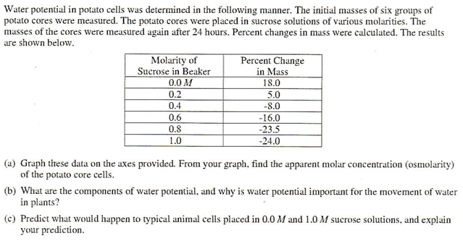

3. Photosynthesis
The rate of photosynthesis may vary with change that occur in environmental temperature, wavelength of light, and light intensity. Using a photosynthetic organism of your choice, choose only ONE of the three variables (temperature, wavelength, , or light intensity) and for this variable
- design a scientific experiment to determine the effect of the variable on the rate of photosynthesis for the organism
- explain how you would measure the rate of photosynthesis in your experiment
- describe the results you would expect. Explain why you would expect these results.

Protein synthesis
Protein synthesis is vital for cell growth and metabolism.
a. Describe transcription and translation.
b. Identify similarities between transcription and translation.
c. Identify differences between transcription and translation.
d. Describe structural changes that can occur in a protein after translation to make it function properly.

Mitosis/Meiosis

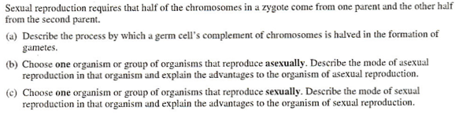

Gene expression

- Explain how an inducible operon regulates gene expression in prokaryotes.

b. Why does an organism use an operon in order to regulate gene expression

c. Name 1 other way organisms can control protein activity

7. Enzymes
