Potential Free Response Topics

- Chi-Square Genetics Problem

Problem 1. In a flowering plant, white flowers (B) are dominant over red (b), and short plants (E) are dominant over tall (e) plants. When two double heterozygote (BbEe) plants were crossed, the resulting phenotypes were observed:
White, short = 206
Red, short = 83
White, tall = 65
Red, tall = 30
Perform a chi-square test to determine if the traits follow a Mendelian inheritance pattern.

Chi Square = 4.323 < 7.815 Accept null because the chi square value is less than the critical value (from the chart). The difference between the observed and the expected is small enough that that difference is due to chance. This means the inheritance pattern is Mendelian.

Problem 2. In dogs, the Black allele B is dominant to the brown allele b for fur.
A pair of dogs (one brown and one black) were bred and had 20 puppies. 13 puppies were black and 7 were brown.
Calculate the chi-squared value for the null hypothesis that the black haired parent was heterozygous for the fur color gene. Give your answer to the nearest tenth.
Is the null hypothesis accepted or rejected? EXPLAIN what accepting or rejecting the null hypothesis means in terms of this observed result and the proposed null hypothesis.

Chi-Square = 1.8 < 3.84. Accept the null …

2. Water Potential/Osmosis
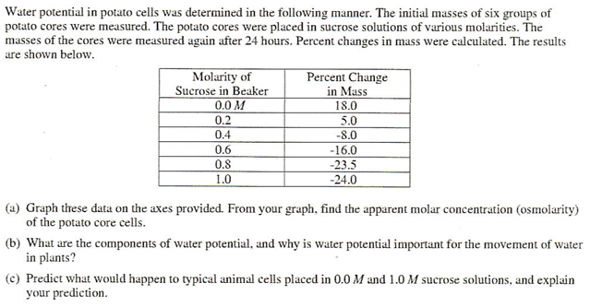
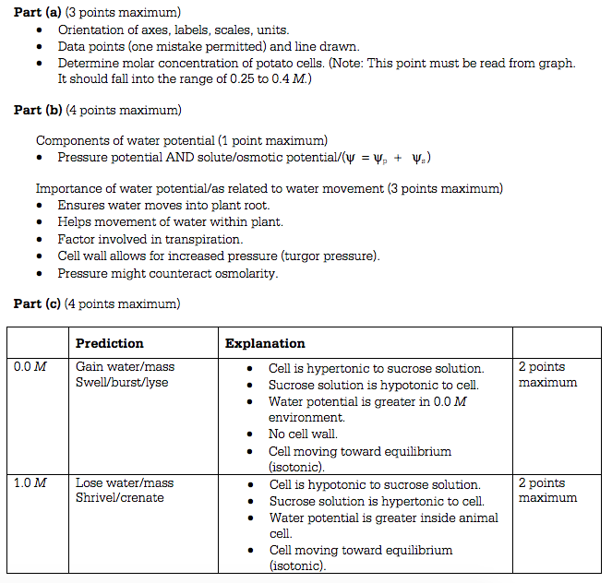

3. Photosynthesis
The rate of photosynthesis may vary with change that occur in environmental temperature, wavelength of light, and light intensity. Using a photosynthetic organism of your choice, choose only ONE of the three variables (temperature, wavelength, , or light intensity) and for this variable
- design a scientific experiment to determine the effect of the variable on the rate of photosynthesis for the organism
- explain how you would measure the rate of photosynthesis in your experiment
- describe the results you would expect. Explain why you would expect these results.

Organism, variable, prediction for results, identify dependent and independent variables
Measure rate of photosynthesis with either co2 consumption or o2 output
Explanation of results (temp increases metabolic rates up to point of proteins denaturing. Wavelength varies on wavelength. The wavelength that has greater absorbance should have a higher rate of photosynthesis b/c more energy to drive light dependent reaction. Light intensity = more energy for light dependent reaction

Protein synthesis
Protein synthesis is vital for cell growth and metabolism.
a. Describe transcription and translation.
b. Identify similarities between transcription and translation.
c. Identify differences between transcription and translation.
d. Describe structural changes that can occur in a protein after translation to make it function properly.

Mitosis/Meiosis

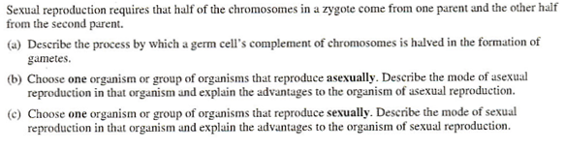
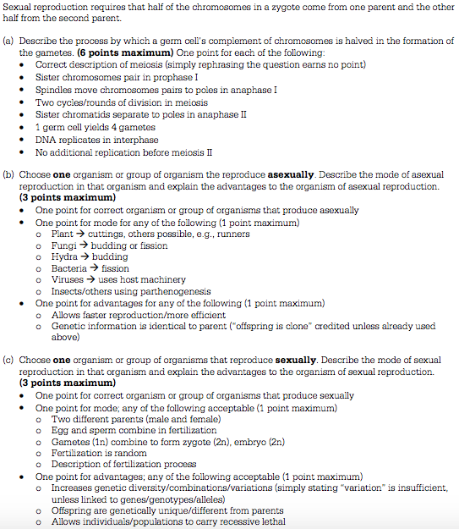
Gene expression

- Explain how an inducible operon regulates gene expression in prokaryotes.

b. Why does an organism use an operon in order to regulate gene expression

c. Name 1 other way organisms can control protein activity
Inducible operon starts off with the repressor protein active and bound to the operator. When an inducer molecule is active, such as lactose, this binds to the repressor protein, changes its shape, making the repressor no longer able to bind to the operator. This allows RNA polymerase to bind to the promoter region and transcribe the genes of the operon. The operon is now on.

Save energy!

Epigenetics, positive control of operons, cell communication, repressible operons, and others

7. Enzymes
